elongllery


Access: pre-visit information Visiting Geelong Gallery

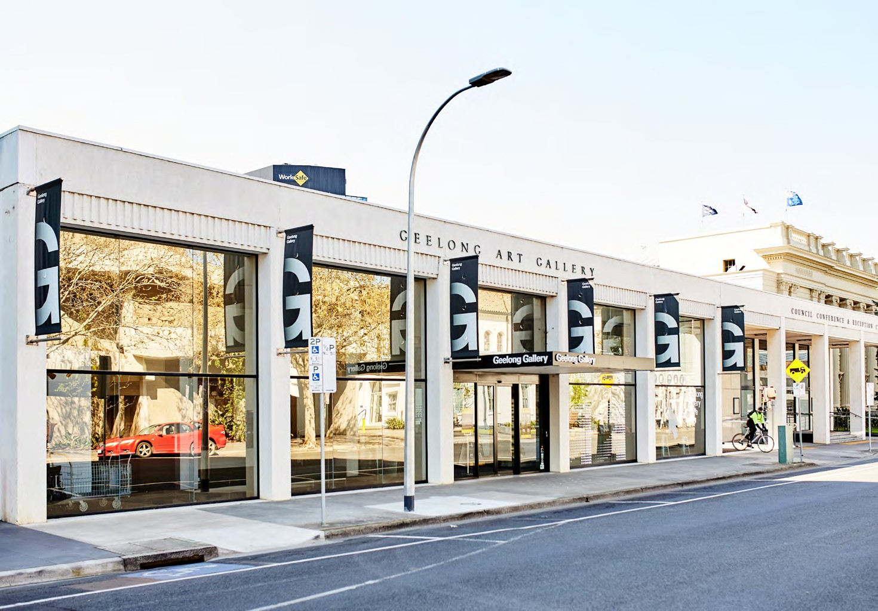

Geelong Gallery
You can access Geelong Gallery via the main entrance, located at
55 Little Malop St Geelong VIC 3220

Parking
Weekday metered parking and free 2–hour parking on weekends is located in Little Malop St, Atchison Pl, Fenwick St and Ryrie St. The civic car park located on Gheringhap St opposite the Town Hall offers parking Monday to Thursday from 7:30am to 6:00pm, Friday, Saturday and Sunday 7:30am to midnight (free parking after 6:00pm on Friday, all day Saturday and Sunday)
Accessible free and ticketed
disabled parking is available on
Little Malop Street.

Geelong Gallery
Little Malop Street entrance
Photographer: Hails & Shine

Geelong Gallery acknowledges the Traditional Owners of the land on
which it is sited, the Wadawurrung People of the Kulin Nation.

We pay our respects to their Elders, past, present and emerging.

Facilities
Level access and wayfinding

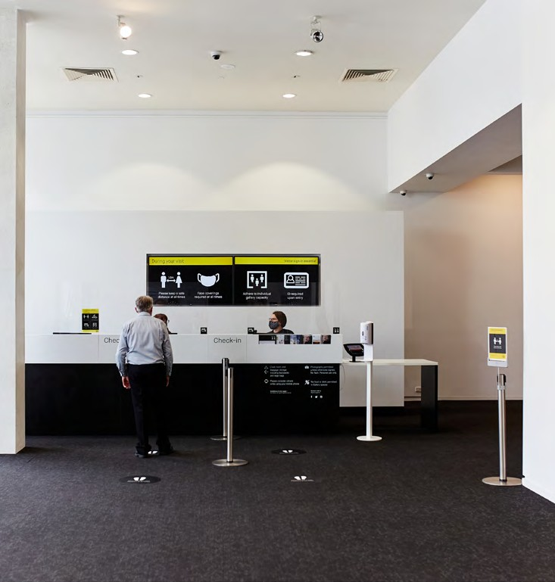
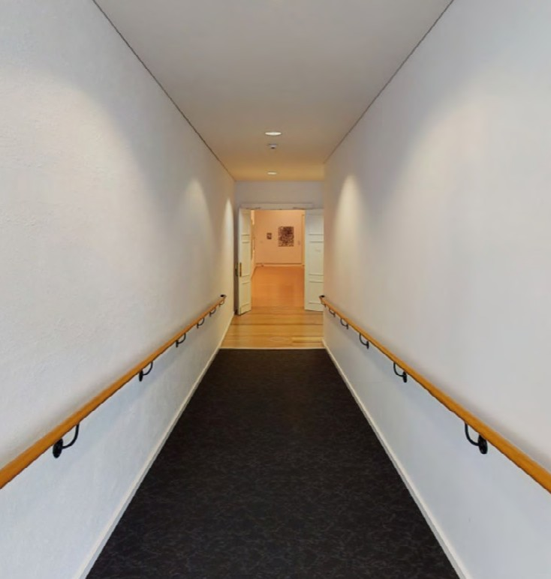
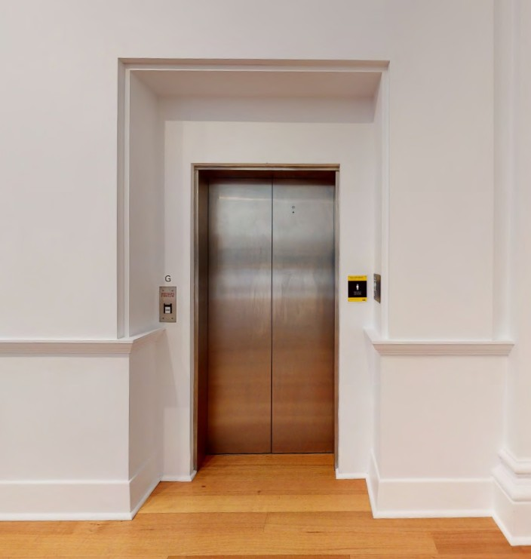

Geelong Gallery Foyer
Our Visitor Services team will welcome you in the Gallery Foyer. Access to our ‘Temporary exhibition space’ is level from the Gallery Foyer, to the right of the reception desk.

Ramp
Access to the main Galleries is via
a ramp, located on the right side of
the foyer, next to the Geelong Gallery Store.

Lift
Access to the Decorative arts gallery and bathrooms is via the lift, found in the Hitchcock Gallery, to the right of the staircase.

Navigating the Gallery
10

1
Visitor Services desk

2
Temporary exhibition space

3
Sidney Myer gallery

4
McPhillimy gallery

5
Richardson gallery

6
Max Bell gallery

7
Douglass gallery

8
Hitchcock galley

9
Learn space

10
Decorative arts gallery

11
Geelong Gallery Store


Entrance
(Little Malop St)
9
8
7
5
2
6
3

4
1
11

Additional information

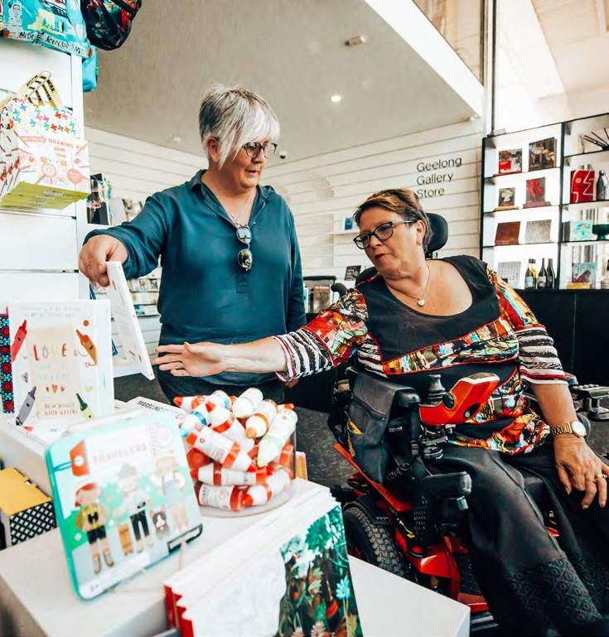

Wheelchairs

Customer Service
Our staff will accommodate all needs. Please ask and we will assist you.

Conditions of entry
Please refer to the Gallery website for up-to-date conditions of entry: geelonggallery.org.au/visit

Gallery Geelong
55 Little Malop Street Geelong VIC 3220 Australia T 03 5229 3645

Thank you
Thanks to Ainslee Hooper Consulting for supporting Geelong Gallery in the development of this pre-visit information.
Wheelchairs are available at no charge from reception. To reserve a chair for your visit, please contact Visitor Services on
03 5229 3645

Toilets
All-Gender, wheelchair access, baby change, female and male toilets
can be found on the lower level of Geelong Gallery, to the right of the staircases. Wheelchair access is via
the lift.

Guide Dogs

Geelong Gallery Store Geelong Gallery, 2019 Photographer: Moby Dick

Guide Dogs and other registered assistance dogs are welcome in all spaces at Geelong Gallery.

Braille and raised letter signage

All facilities way-finding signage at Geelong Gallery include Braille and raised letters.

